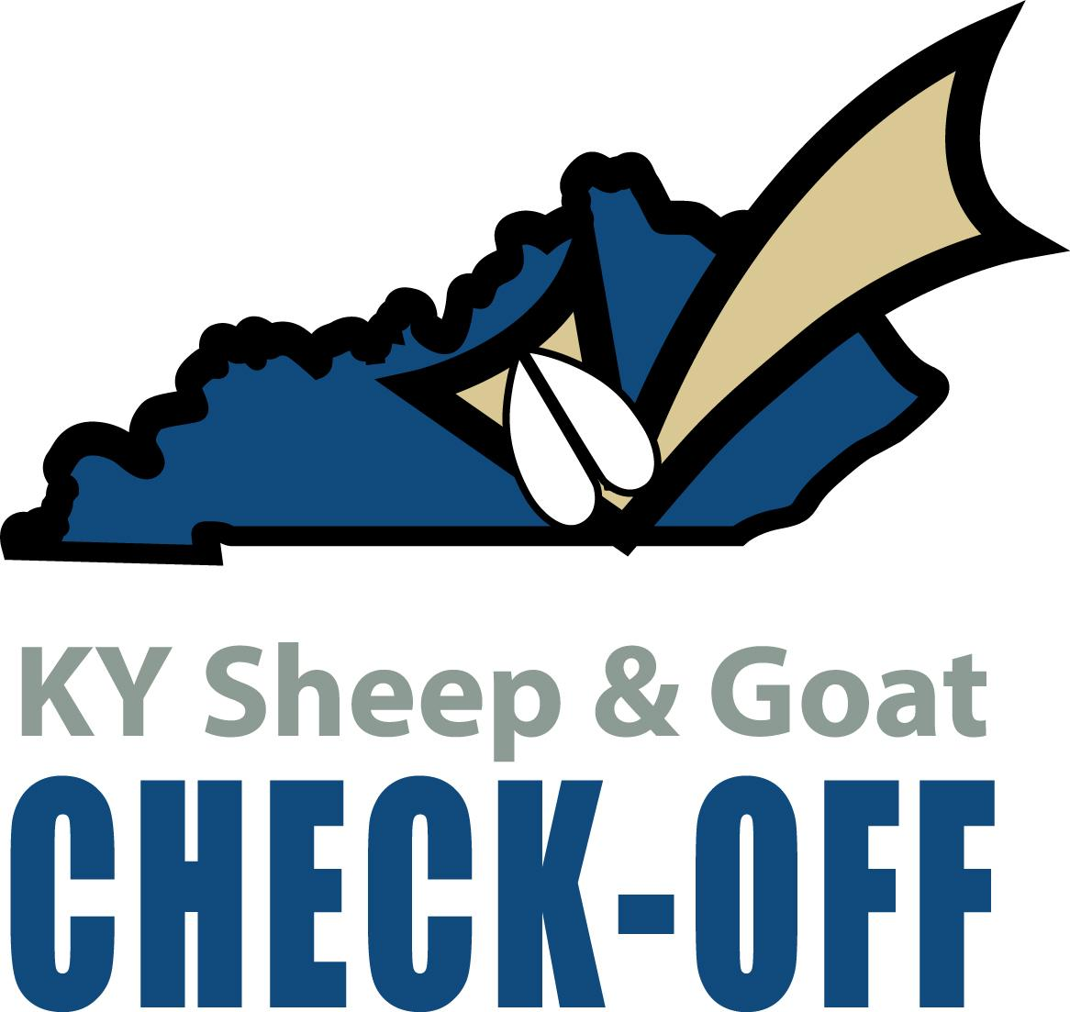
Kentucky Sheep and Goat Check-Off Program Small Ruminant Boot Camp Application

Overview: The Kentucky Sheep and Goat Council will use check-off dollars for four, $1500 Small Ruminant Boot Camp grants in 2026. Funds are available to provide small ruminant production education with resources available from Checkoff in nutrition, health, quality assurance, hoof care, and parasite management. Funds are reimbursement grants and will not be issued until all guidelines of the grant agreement are met.

Eligibility: Funds will be made available to Cooperative Extension Areas within the state of Kentucky.

Funds: Maximum request is $1500

Timeline: Applications open February 1, 2026 and will close when four camps have been scheduled. Programs must be completed by December 30, 2026.

Grant Requirements:
- Grantee must provide an application and proposed budget for approval.
- Grantee must use the Kentucky Check-Off logo on all promotional materials such as flyers, websites, social media, etc.
- Post program evaluation must be administered and results shared with Checkoff Board in a final report that includes receipts before funds are released.

The Checkoff Board wants to encourage Cooperative Extension Agents for Agriculture & Natural Resources to team up and offer a Small Ruminant Boot Camp in an area. The program topics and plan are up to the discretion of the area, however the Checkoff board is willing to provide resources and help securing speakers for your event. We know that producer needs vary across the state and want you to be able to plan a program most beneficial to your clientele.

Checkoff has the following items available (contact Kelley Yates to request):
- Registrations can be taken online through the KSGDO website
- Instructor options for a variety of topics
- Program supplies like microscopes, hoof trimmers, biosecurity supplies, parasitology kits, equipment kit, record books, and trimming stands
- Handouts on a variety of topics to share with participants
- Help with ordering FAMACHA cards; each card is $25 (Please note- FAMACHA can only be taught by a certified instructor!)
- Program evaluations and results

Grant funds may be used to purchase:
1. Hoof trimming kits, including the following items: hoof trimmers (ARS 140DXR Hoof Trimmers most highly recommended) and treatment products as outlined in the Hoof Care handout, which will be provided to you upon approval of your application. (No antibiotics allowed with grant funds.)
2. Biosecurity supplies, including: plastic boots, bleach foot bath, plastic gloves, disinfectant for cleaning equipment
3. Speaker expenses including: travel, food, honorarium
4. General supplies like copies, pens, and notebooks.
Send completed applications to:

Kentucky Sheep and Goat Check-Off Program
c/o KSGDO
1619 Bypass Road, PMB 159
Winchester, KY 40391
or
email to: kyates@kysheepandgoat.org

Questions - kyates@kysheepandgoat.org or (502) 682-7780

Kentucky Sheep and Goat Check-Off Program
Small Ruminant Boot Camp

Name of Group/Extension Area: _________________________________________________
Contact Person: ________________________________________________________________

Address: ______________________________________________________________

City: __________________________ State: ________________ Zip: ____________

County(ies): _______________________ Phone Number : (_____) __________________

Cell Number: (_____) ________________ E-mail: _____________________________

Date of Event: _________________________ Location: ________________________

Contact Person (if not same as above): __________________________________

How many projected participants:_____________________________________

Project Budget (recommend contacting Kelley Yates to discuss before submission):

Income:
KY Sheep and Goat Check-Off Funds | $1500
Other: (specify)
Total Income:
Expenses:
Total Expenses:
Remaining Balance:

